Intro to Programming (Python)

Assignment 06

# Overview

In this activity, you learn to work with functions and a simple class by creating a script and documenting your knowledge. You also learn how to post work to a GitHub repository that includes a GitHub web page.

This assignment includes the following tasks:

1. Watch the module videos.
2. Review some web pages.
3. Watch the external videos.
4. Apply your knowledge.
5. Document your knowledge.
6. Post your files to GitHub
7. Post your GitHub link
8. Submit your work.
9. Peer Review (Not Graded)

**Tip:** Consider the following questions while you work through the module to help you focus:

* What is a function?
* What are parameters?
* What are arguments?
* What is the difference between parameters and arguments?
* What are return values?
* What is the difference between a global and a local variable?
* How do you use functions to organize your code?
* What is the difference between a function and a class?
* How do functions help you program using the “Separations of Concerns" pattern?
* How are the debugging tools used in PyCharm?
* What is a GitHub webpage?

# Assignment Steps

The following assignment steps ask you to read about, perform, and write about programming.

***Note:*** *Course assignments help you learn through* ***reading****,* ***watching*** *demonstrations,* ***performing*** *programming in Python, and reflecting on what you learned through* ***writing****. You are strongly encouraged to continue your learning by experimentation.*

## Step 1 - Watch my Video Lecture

Please watch my course lecture for this module. You can find this module lecture(s) here: [ITFdn 110 - Python Course Videos](https://youtube.com/playlist?list=PLfycUyp06LG9fZllIqBrxLcNV4CR50HEX)

## Step 2 - Read a book chapter

Please **read chapter six** in your textbook. You **do not have to perform the exercises or type in the code**, but it is best if you open the script files as you read about them. You can find the downloadable **book files** **on Canvas** for your convenience.

## Step 3 - Web pages

Please review the following web pages. These are shorter than the book and provide online resources you can use later.

* <http://www.learnpython.org/en/Functions>(external site)

## Step 4 - External Videos

Please watch this video. It explains things a bit differently, which helps with learning!

* Creating Functions: <https://youtu.be/qO4ZN5uZSVg>(external site)

## Step 5 - Apply your knowledge

Now that you have reviewed the websites and videos, **modify** a script that manages a "ToDo list." This project is like the last one, but different enough to be a challenge.

**I have provided a starting template to I want you to modify and use for your program** called "Assigment06_Starter.py". Currently the code loads data from a file into a Python List of Dictionary objects. However, the code only uses a few functions, and **your job is to add more functions to organize the code.** You may note that it is both easier and harder to work with someone else's code, and that is part of the assignment.

a. **Create** a new sub-folder called Assignment06 inside the _PythonClass folder.

b. **Create** a new project in PyCharm that uses the _PythonClass\Assignment06 folder as its location

c. **Add** the starter file, "Assigment06_Starter.py," to your project.

d. **Add** code to your script that performs the assignment’s task. Don't forget to update the changelog in the script's header.

e. **Run** the script in BOTH PyCharm and an OS command/shell window and capture images of it working on your computer.

f. **Verify** that it worked, by locating the text file and opening it in a text editor. The file should be in the same folder as your script if you used the correct, **relative** file path!

## Step 6 - Post your Files to GitHub

In this module, you need to **post** your files on a public **GitHub repository** so that others may review it. Please post **your Python file**.

a. **Login** to <https://github.com> (*Make a new account if needed!*)

b. **Create** a repository called **"*IntroToProg-Python-Mod06" under your account.***

c. **Upload** both of your files to the repository.

d. **Commit** the changes to save your work.

**Important: You are creating a new GitHub repository in assignment 6 than you did in assignment 5. Using a different repository gives you practice managing multiple repositories and is part of the assignment.**

## Step 7 - Add a GitHub Web Page

You need to **add a GitHub webpage to your repository**. In this assignment, so you use the following code to get you started (Listing 1).

**Important:** GitHub made changes to the process of creating a web page. Please follow the instructions in this link:

<https://docs.github.com/en/pages/getting-started-with-github-pages/creating-a-github-pages-site>

# Module06 Website

---

[Google Homepage](https://www.google.com "Google's Homepage")

[GitHub Webpage Code CheatSheet](https://github.com/adam-p/markdown-here/wiki/Markdown-Cheatsheet)

Listing 1

***Note:*** *In the next assignments, you will "Document your knowledge" in the GitHub page like you do in the Word Document, but* ***for now, just use the simple code I provide****. I have allowed time for you to do* ***learn to make better pages in assignment 7****.*

## Step 8 - Document your knowledge

**Create** a document describing the steps you took while performing this assignment. **Use** screenshots and code samples to explain the process, just as your book, my programming notes, and the web pages you reviewed.

**Note**: Make sure you put it in a proper, professional-level formatting! It does not have to be perfect, but if you turn in a simple blob of text, you will not get credit for it! Here is a link that may help you understand what I am looking for: https://youtu.be/9ojhSW9ljjo (External Site)

***Important:***

1. *Copy and paste the URL for your new GitHub site into your knowledge document (Figure 2). This link makes grading a lot easier and is a big help! Thanks!!*

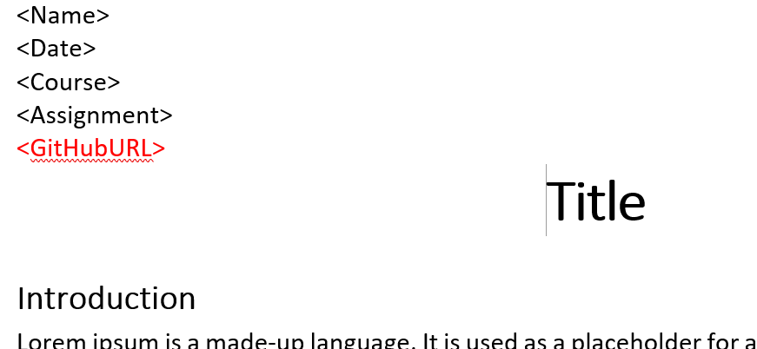

Figure 2. Adding your GitHub URL to your Word document

**Save** the document as a **.pdf file** this time and **upload** it to your repository. (You can view PDF files on GitHub without having to download them!)

## Step 9 - Post a Link to GitHub

You need to share your work using the Canvas discussion board. To do so, you must **create** **a post with a link to your GitHub site**. Other students will use this link to perform a peer review.

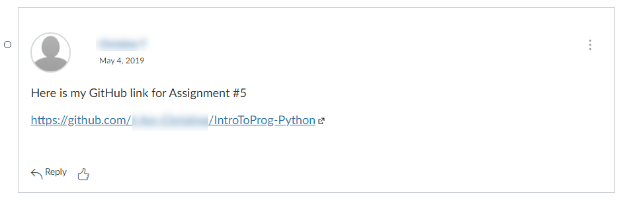

Figure 3. Posting a link to your GitHub repository

***Important:***

1. *Post only on the special discussion board called "Assignment 06 Documents for Review!"*

## Step 10 - Submit your work

Even though you have posted your file on GitHub, **you still need to submit your Python script and Word document as a Canvas assignment** for grading. So, place your document and python script in the Assignment06 folder. Zip this folder into a “.zip” file, then upload the .zip file to the class assignment page.

***Important:***

1. ***Upload*** *your work* ***to the Canvas*** *assignment’s as a* ***Zip file****.*
2. ***Post*** *a link to your GitHub site* ***on the******assignment textbox****.*

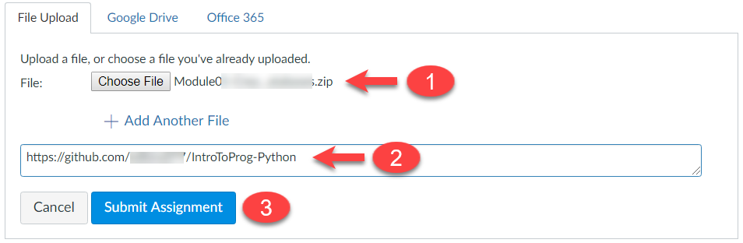

Figure 4. Posting your zip file to Canvas

## Step 11 - Perform a Peer Review (Not Graded!)

After you have posted your link to GitHub and submitted your assignment, go to the "Assignment 06 Documents for Review!" discussion board and **select another student's post and review.** Follow the link they posted and review their files on GitHub. **This is an informal review** that **does** **not affect** either your or their **grade**. **Try to pick someone's link that has NOT been reviewed yet, even if you have to wait a few days for one to appear!**

NOTES

* **Post** your comments as a reply to their posting so the review will be nested under the other student's posting.
* **Make sure** to say two things that you liked about their work
* **Make sure** to say one thing that could make the work better

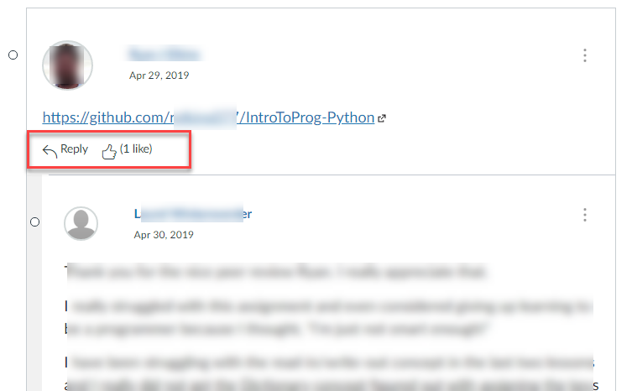

Figure 5. Doing a peer review

Congratulations! You are done!